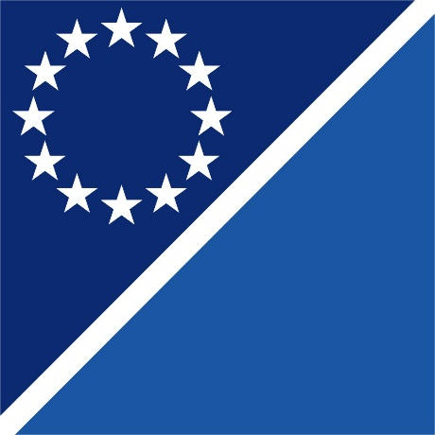

RAI
Regional Anti-Corruption Initiative

Programme Framework
2026 -2028

Prepared by RAI Secretariat
Contents
Abbreviations 2
Executive Summary 3
Background 4
Strategic Context and Analysis 5
Stakeholder analysis 6
Priority Areas and Objectives 8
Cross-Cutting Topics 10
Program Initiatives 10
Potential Areas of Interest 11
Monitoring, Evaluation, and Reporting 12
Strategic Communication and Outreach 13

Abbreviations
ADA - Austrian Development Agency
CEI - Central European Initiative
CoE – Council of Europe
CPL - Corruption Proofing of Legislation
CRA - Corruption Risk Assessment
CSO - Civil Society Organization
CSD – Center for the Study of Democracy
EC - European Commission
EU - European Union
GI-TOC - Global Initiative Against Transnational Organized Crime
GRECO - Group of States against Corruption
MARRI -Migration, Asylum, Refugees Regional Initiative
MoU - Memorandum of Understanding
OECD - Organization for Economic Co-operation and Development
OSCE - Organization for Security and Co-operation in Europe
RAI - Regional Anti-Corruption Initiative
RCC - Regional Cooperation Council
ReSPA - Regional School of Public Administration
RYCO – Regional Youth Cooperation Office
SEE - South Eastern Europe
SG - Steering Group
UNCAC – United Nations Convention Against Corruption
UNODC - United Nations Office on Drugs and Crime
WB - Western Balkans
WBF – Western Balkans Fund

Executive Summary
The Regional Anti-Corruption Initiative (RAI) is an intergovernmental organization, established in 2000, with nine member countries and five observers. RAI provides a platform for the exchange of good practices and coordinated action in the fight against corruption.

The mandate of RAI is to lead and support regional efforts in the prevention and fight against corruption, promoting integrity, transparency, accountability and good governance in Southeast Europe. RAI aims to enhance national capacities, promote regional cooperation, and ensure alignment with European and international anti-corruption standards and commitments.

In addition to technical expertise and coordination, RAI has a clear mandate to advocate for political and legal environments that enable sustainable anti-corruption reforms. This includes providing support for the development of policies and frameworks that close opportunities for corruption, while fostering public trust in governing institutions.

To raise and sustain momentum, RAI’s strategic directions will remain closely aligned with the EU accession agenda, particularly with regard to international standards in anti-corruption. This approach also takes into consideration the 2025 Rule of Law Report, the 2024 Enlargement Reports, the 2024 UNODC Annual Report, and GRECO’s 25th General Activity Report (2024). RAI’s efforts will focus on strengthening member countries’ capacities to prevent and combat corruption, enhancing transparency, and engaging civil society, youth, the business community, and academia. This includes strengthening member countries to prevent and combat corruption, boosting transparency, and engaging civil society, youth, business community and academia. RAI will enhance it’s support for effective corruption prevention and repression mechanisms, as well as digitalisation to support anti-corruption activities. It will also stay aligned with the SEE 2030 Strategy, backing regional cooperation in priority sectors and improving the quality of justice and public institutions in Southeast Europe. RAI will also support its member countries implement anti-corruption commitments, progress EU accession objectives, meet OECD accession criteria, and foster a culture of integrity, and exchange good practices and experiences between member countries.

The RAI Programme 2026–2028 is developed in accordance with the Memorandum of Understanding concerning Cooperation in Fighting against Corruption through the South Eastern European Anti-Corruption Initiative (MoU), in line with the RAI Strategic Document and national priorities of the RAI member countries. The Programme sets the framework for advancing integrity, accountability, and resilience across Southeast Europe, building on the achievements of the 2023–2025 cycle, and addressing the evolving challenges in preventing and combating corruption across Southeast Europe. The Programme focuses on addressing the needs of RAI member countries in the implementation of their initiatives directed to strengthening good governance and accountability, preventive and repressive mechanisms, fostering resilience of institutions, enabling deeper regional and international cooperation, including necessitate institutional upgrade of RAI.

The Programme 2026-2028 is built around three objectives: reinforce good governance and accountability; advance institutional development and consolidation; and strengthen regional and international cooperation in a dynamically evolving global setting.

Background

The rule of law is an essential precondition for a stable and predictable economic environment, giving the RAI Member Countries a global competitive edge. The determination to foster a stronger and more competitive region relies heavily on ensuring that the rule of law is effectively protected.

“The enlargement process continues to be merit-based and depends on the objective progress made by each of the partners. This requires determination to implement irreversible reforms in all areas of EU law, with special emphasis on the fundamentals of the enlargement process. Democracy, the rule of law and fundamental values will continue to be the cornerstones of the EU's enlargement policy. EU membership remains a strategic choice”.

RAI is committed to supporting the preservation of accountable society and trustworthy governance systems. At the same time, RAI works to support the institutions of the RAI countries through the implementation of instruments to successfully challenge those who undermine governance through corrupt practices, ensuring that no actor remains above scrutiny. By combining advocacy, accountability, and technical cooperation, RAI positions itself as both a policy driver for integrity in the region.

The Programme 2026–2028 continues the mandate of RAI to facilitate anti-corruption reforms, focusing on priority areas identified through consultations with member countries, partners, and donors. Over twenty-five years, RAI has established itself as a hub for dialogue, knowledge exchange, and cooperation. The Programme 2026–2028 draws lessons from the 2023–2025 Work Plan, while responding to emerging needs identified through consultations with member countries.

Vision: RAI envisions a Southeastern Europe where governance is transparent and accountable, corruption no longer undermines development, and citizens can rely on fair institutions and the rule of law. The region is a community in which cooperation, integrity, and trust underpin sustainable development, stability, and European integration.

As a platform that facilitates dialogue, exchange, and mutual learning, RAI promotes the transfer of best practices of its member countries, supports alignment with international and European standards and provides opportunities for cross-border cooperation that strengthen resilience through the integrity of the institutions and organisations across the region.

Mission: To advance the fight against corruption and integrity through regional cooperation, technical assistance and innovation, enabling member countries to align with international standards and deliver sustainable reforms.

Strategic Context and Analysis

Ongoing EU integration processes, increased demand for transparency and regional cooperation under the Berlin Process, and the Western Balkan countries’ reform agendas all incorporate steps to improve the combat against corruption, as sustainable development and accession require transparent governance and strong institutions. Economic growth depends on fair competition and investor confidence, which can only be secured by reducing corruption risks. Similarly, reform agendas prioritise strengthening the rule of law, judicial independence, and public administration, all of which directly target systematic corruption. On the EU path, progress is measured largely by the credibility of anti-corruption efforts, making integrity, accountability, and good governance essential conditions for accession, which is directly connected with economic growth, fair competition and investors’ confidence. Aspiration of EU Member states, that are also RAI members, to become part of OECD and the necessary activities that follow, as well as requests from candidate countries to demonstrate commitment to transparency, good governance, and adherence to international anti-bribery and integrity standards, are also directions of RAI Programme activities in the next period. All RAI Member countries emphasised priorities such as asset declaration verification, conflict of interest, corruption risk assessments (CRA), corruption-proofing of legislation (CPL), whistleblowing, lobbying and asset recovery.

Additionally, it has been observed that countries in the region face significant challenges in building sufficient institutional capacities to combat corruption. Illicit financial flows continue to occur, cybersecurity threats are on the rise, and there are persistent corruption risks in vulnerable sectors such as security, health, education, procurement, and public-private partnership processes. These issues pose challenges for new initiatives of the RAI, as it seeks to align its programs with the United Nations Convention Against Corruption (UNCAC), GRECO recommendations, OECD standards, the EU acquis, and regional anti-corruption strategies.

Stakeholder analysis
To reinforce inclusive regional cooperation and strengthen ownership of its initiatives, RAI will actively engage stakeholders to ensure policy coherence and accountability through the following key actions:
- Broadening partnerships by involving diverse stakeholders to ensure that regional anti-corruption priorities and implementation processes reflect shared ownership and inclusive perspectives;
- Strengthening internal coordination by aligning closely with compliance requirements and reporting mechanisms, thereby enhancing transparency, credibility, and the overall effectiveness of RAI-led initiatives;
- Fostering inclusive governance through cooperation with media, civil society, business community and youth, acknowledging their vital role in shaping public discourse, advancing accountability, and ensuring the sustainability and legitimacy of regional cooperation efforts.
  - Key Stakeholders and Partners:
RAI, through its Secretariat, establishes cooperation with mainly Integrity bodies (Anti-corruption Agencies/Commissions), relevant Ministries of Justice, Security, and Internal Affairs across its member countries. Also, through project activities, cooperation involves judicial institutions, law enforcement agencies, the Ministry of Defense, relevant environment authorities, audit offices, administrations for the prevention of money laundering, etc.

Since the training of civil servants, police, judicial and prosecutorial officials and officers is relevant in implementing RAI Programme activities, RAI’s cooperation with judicial, prosecutorial and police academies, as well as other national training institutions for capacity building and specialised training for legal professionals, is of the utmost importance.

From the perspective of international organisations and Initiatives, long-term partnerships RAI have with the EU Commission and EU Delegations, UNODC, RCC, and CEI. Also, a partnership with other regional organizations, RYCO, ReSPA, WBF, MARRI, Transport Community, Energy Community. Nevertheless, RAI is keeping up with relevant UNCAC, GRECO, OECD requirements to be able to provide its members with necessary assistance, if necessary. RAI is dedicated to continuing its cooperation with civil society organizations, think tanks, academia, investigative journalists, and all other stakeholders in the area of anti-corruption.

  - Stakeholder Engagement and Resources
RAI will leverage partnerships with CSOs, academia, private sector associations, and international organisations. It will explore co-funding through EU funds and other donors. Member countries will be consulted regularly to ensure alignment with national needs.

- Member countries: through the Steering Group, national coordinators, and focal points for particular activities and projects.
- Civil society and media: watchdog role and advocacy partners.
- International organisations: EU, UNODC, GRECO, OSCE, OECD, CoE etc.
- Academia, youth, and business community: joint projects on integrity, compliance, and anti-corruption education.

SWOT analysis of RAI Programme

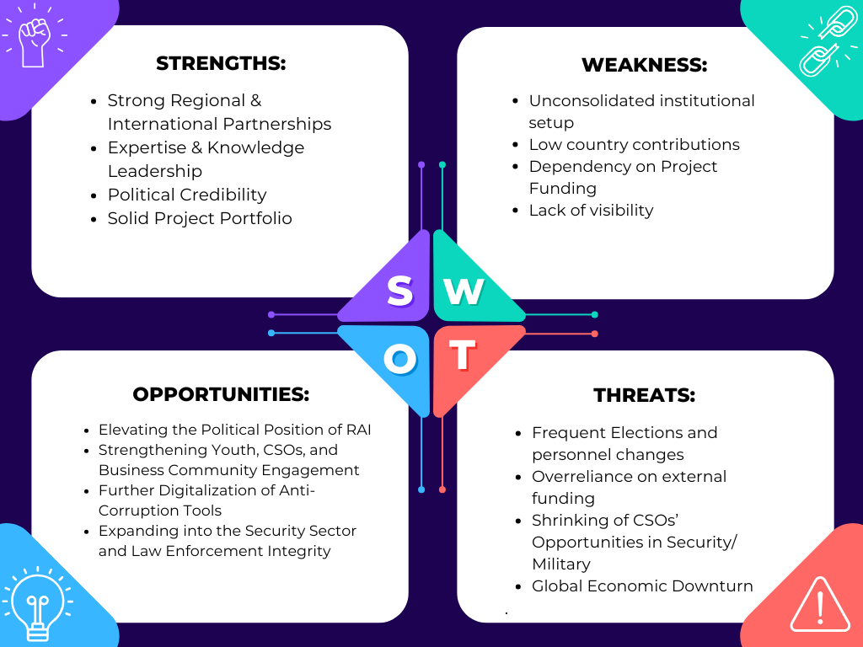

Priority Areas and Objectives
The Programme is structured around three main pillars, linked to the three strategic objectives, and which at an operational level are translated into a set of key activities.

Strategic Objective 1: Strengthening Good Governance and Accountability

Goal: To enhance transparency, accountability, and integrity in public administration across Southeast Europe through preventive mechanisms, institutional capacity building, and multi-stakeholder engagement.

Rationale: Effective governance and accountability systems are fundamental to preventing corruption and building public trust. This priority area addresses the need for stronger preventive mechanisms, institutional capacity, and societal engagement in anti-corruption efforts.

Key Activities:

  - Strengthen preventive anti-corruption mechanisms
  - Enhance institutional capacity and knowledge hub for integrity and accountability
  - Foster multi-stakeholder engagement in anti-corruption efforts

Strategic Objective 2: Institutional Development and Consolidation

Goal: To strengthen the institutional capacity of RAI, visibility, and impact as a leading regional anti-corruption platform.

Rationale: A stronger, more effective RAI is better positioned to support member countries in their anti-corruption efforts. This priority area addresses internal organisational needs to enhance the effectiveness and sustainability of RAI.

Key Actions:

  - Consolidation of organisational documents of RAI
  - Enhance the visibility and international standing
  - Improve operational efficiency and effectiveness

Strategic Objective 3: Facilitation of Regional and International Cooperation in a Changing Global Context

Goal: To enhance regional and international cooperation in preventing and combating corruption, addressing emerging challenges, and leveraging new opportunities.

Rationale: Corruption is increasingly transnational, requiring coordinated responses across borders. This priority area addresses the need for stronger regional and international cooperation to effectively combat cross-border corruption and address emerging global challenges.
Key Actions:

  - Support better cross-border coordination and cooperation
  - Address emerging corruption risks and challenges
  - Strengthen partnerships with international organisations

Cross-Cutting Topics
Gender mainstreaming

Since integrating a human rights-based approach into its policies in 2016, RAI has prioritised gender mainstreaming as a core element of its anti-corruption and human rights initiatives. RAI actively promotes anti-discrimination efforts by incorporating diverse perspectives, such as gender and disability, into impact assessments. Gender considerations are embedded across all projects and programs, encouraging partners and beneficiaries to adopt a gender-aware approach during implementation. This includes collecting and analysing gender-disaggregated data to promote inclusivity and equity, as well as maintaining balanced gender representation within the Secretariat itself. By ensuring equal participation of men and women, RAI aims to empower both genders with the knowledge and skills needed to contribute to anti-corruption efforts in their communities effectively. Additionally, the Secretariat commits to using gender-sensitive language in all communications and operations, fostering an inclusive and respectful environment.

Awareness Raising

Public awareness is an important component of anti-corruption efforts. Recognising this, the RAI Secretariat continuously integrates communication elements into its projects to educate the public on the consequences of corruption and the available preventive mechanisms. Without effective awareness, national and regional anti-corruption initiatives risk reduced impact. Raising public awareness also serves to boost enthusiasm and support, encourage self-mobilisation, and leverage knowledge and resources. The Secretariat actively utilises social media platforms, including LinkedIn, Facebook, and Twitter, to share stories, narratives, and visuals that present facts and data in an engaging and accessible manner. This approach helps build a community around anti-corruption issues and fosters greater understanding.

Program Initiatives
- Regional Capacity-Building and Peer-to-Peer Exchanges for Integrity Bodies, Judiciary, and Law Enforcement.
- Facilitate regular workshops, seminars, and policy dialogues to enhance knowledge sharing, best practices, and collaborative strategies among regional agencies. Encourage joint activities to address cross-border corruption issues and promote mutual legal assistance agreements to strengthen regional cooperation.
- Digital Platforms for Data Exchange, Training, and Monitoring of CRA, CPL, Whistleblowing, and Asset Recovery.
- Incorporate interactive e-learning modules, webinars, and virtual mentoring programs to expand training reach.
- Implement multimedia campaigns utilising social media and community outreach to raise awareness about the importance of integrity and the dangers of corruption. Collaborate with universities, CSOs, journalists, the business community, and media outlets to promote investigative reporting and foster a culture of transparency.
- Produce policy briefs, guidelines, and best practice manuals to assist governments and organisations in designing targeted interventions.

Potential Areas of Interest
Digital Integrity and Data-Driven Governance

- Promote the International Treaty on Data Exchange for verification of asset declarations across SEE borders.
- Utilise digital opportunities for a knowledge-sharing platform on anti-corruption.
- Enable access to the list of public registries necessary for the implementation of the Treaty.

Youth Engagement and Integrity Education

- Establish a Regional Youth Integrity Network to empower young people as watchdogs and advocates.
- Develop learning tools for schools and universities focused on ethics, civic engagement, and whistleblowing awareness.

Corruption in Green and Climate Finance

- Map corruption risks in green transition projects (renewable energy, waste management, climate adaptation).

Corruption-driven migrations

- Strengthening research, investigative reporting, and dedicated data centres can better document and understand the need for corruption-driven migrations.

Implementation Plan and Timeline

- 2026: Launch of Programme, operationalisation of the International Treaty pilot phase, scaling CRA/CPL initiatives, capacity-building events.
- 2027: Improvement of asset recovery cooperation, mid-term review and regional awareness campaigns.
- 2028: Consolidate results, produce regional assessments, and prepare the 2029–2031 Programme.

Monitoring, Evaluation, and Reporting
- Framework: Results-based management with SMART indicators.
- External programme and institutional evaluation and audit.
- Tools: Annual progress reports, mid-term review (2027), final report (2028).
- Accountability: Regular reporting to the Steering Group, donors, and stakeholders.
- Country-specific indicators (e.g., Treaty use, CRA/CPL uptake, whistleblower reports).
- Transparent reporting and comparative assessments across member countries.

  - Risk Management Strategy
- Political risks: mitigated through regional ownership and international anchoring.
- Financial risks: diversified donor base, regulations, and agreements.
- Capacity risks: investment in staff training, technical tools, and peer support.
- Reputational risks: strict transparency, accountability, and ethical standards.

  - Mitigating strategy

- Political risks will be mitigated through strong regional ownership and continuous stakeholder dialogue to ensure adaptability.
- Financial risks will be mitigated by ensuring a diversified and balanced donor portfolio, implementing strong financial management and control mechanisms, and pursuing multi-annual funding arrangements to enhance stability and predictability.
- Capacity risks will be mitigated by strengthening staff competencies through continuous training, investing in modern technical tools, fostering peer learning and knowledge exchange, and conducting regular assessments to identify and address capacity gaps.
- Reputational risks will be mitigated by reinforced clear communication protocols, proactive stakeholder engagement, and independent evaluations to ensure credibility and public trust.

Strategic Communication and Outreach
The strategic communication and outreach aim to enhance the visibility of RAI and its regional/international profile by effectively communicating its anti-corruption efforts to key stakeholders in Southeast Europe and beyond. It emphasises the importance of strategic, transparent, and timely messaging across media, digital platforms, and multimedia content to build understanding, support, and trust.

RAI will promote its achievements through media engagement, social media, and visual content, tailoring messages for diverse audiences, including governments, civil society, youth, media, and other stakeholders. The approach includes collaborating with regional partners and highlighting donor contributions to demonstrate collective impact. RAI will actively support prominent events and discussions that highlight innovation, inclusivity, and multi-sector cooperation in anti-corruption efforts.
ANNEX – Log frame Matrix

Area of intervention | Description of actions | Expected results | Indicators | Partners | Timeframe
Strategic Objective 1: Strengthening Governance and Accountability

1.1 Strengthen preventive anti-corruption mechanisms | 1.1.1 Actions that promote digital tools and access to open data to enhance transparency and empower citizens, civil society, and oversight bodies to actively participate in anti-corruption efforts | Improved promotion of digital tools and initiatives to enhance transparency and empower citizens, civil society, and oversight bodies to actively participate in anti-corruption efforts. | Number of new available tools  Number of accessed data | RAI  ADA  Potential Donors | 2026-2028
1.2 Enhance institutional capacity and knowledge hub for integrity and accountability | 1.2.1 Capacity-building activities for anti-corruption practitioners and other stakeholders | Implemented new capacity-building initiatives to effectively utilise preventive mechanisms and to ensure sustainability. | Number of trainings  Number of participants  Number of trained trainers | RAI  ADA  UNODC  Potential Donors | 2026-2028
1.3 Foster multi-stakeholder engagement in anti-corruption efforts | 1.3.1 Involve government agencies, civil society, youth, business community, other stakeholders, and international organisations in workshops, conferences etc., to discuss the innovative solutions. | Improved involvement of all stakeholders to coordinate efforts and share best practices for corruption prevention. | Number of events  Number of participants  Number of stakeholders involved | RAI  ADA  UNODC  Potential Donors | 2026-2028
Strategic Objective 2: Institutional Development and Consolidation

2.1. RAI institutional development | 2.1.1 Consolidation of organisational documents of RAI | Organisational documents prepared and aligned | Necessary documents adopted | RAI,  ADA,  Potential Donors | 2026-2028
2.2 Enhance visibility and international standing | 2.2.1Develop and implement a comprehensive advocacy and communication strategy to enhance visibility and outreach. | Advocacy strategy developed  Communication strategy developed | Number of events organised by RAI  Number of activities with RAI participation  Number of social media posts and media appearances | RAI,  Potential Donors | 2026-2028
2.3 Improve operational efficiency and effectiveness | 2.3.1 Strengthen monitoring and evaluation systems to improve program effectiveness and demonstrate results. | The monitoring and evaluation system has improved. | Number of annual and progress reports published. | RAI  Potential Donors | 2026-2028
Strategic Objective 3: Facilitation of Regional and International Cooperation in a Changing Global Context

3.1 Support better cross-border coordination and cooperation | 3.1.1 Facilitating the cross-border coordination and cooperation initiatives of the member countries in their reform activities and joint actions aimed at preventing and combating corruption | New initiatives to improve cross-border cooperation in line with relevant standards | Number of initiatives for cross-border activities  Number of participants in events for facilitating cross-border cooperation | RAI  Potential Donors | 2026-2028
3.2 Strengthen anticorruption  measures in the context of an emergency | 3.2.1 Further work on the development of the necessary documents to tackle corruption in the context of an emergency | The development of documents tackling corruption in the context of an emergency | Number of adopted documents | RAI  Other donors | 2026-2028
3.3 Strengthen partnerships with international organisations | 3.3.1 Development of new joint initiatives and activities with UNODC, OECD, OSCE, EU, and regional networks | Increased cooperation in the combat against corruption in SEE | Number of joint initiatives implemented | RAI  Potential Donors | 2026-2028

EU Commission Press release on Enlargement Reports 2024, 30 October 2024.
https://www.rcc.int/
https://www.cei.int/
https://www.rycowb.org/about/
https://www.respaweb.eu/
https://westernbalkansfund.org/
https://marri-rc.org.mk/
https://www.transport-community.org/
https://www.energy-community.org/

